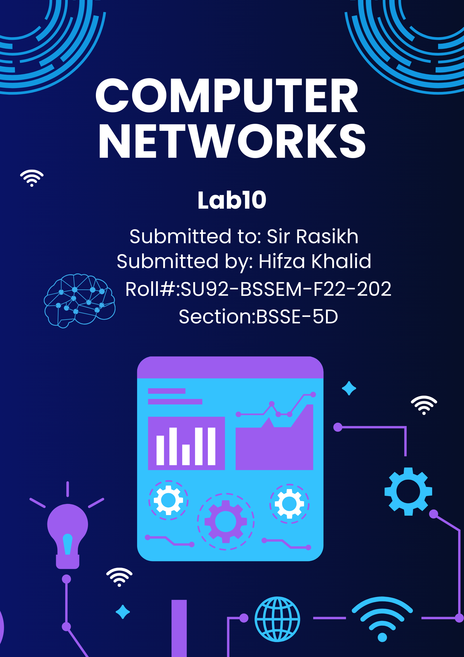

**Discussion About Project**

# **Lab 10 - Task**

## Task 1;

**Research about Topics for Project and submit a deliverables document having:**

* **Organization Name**
* **Number of Floors of the Organization**
* **Number of PC / Server in the system**

**Deliverables Document: Campus Network Design Project**

**Organization Name:**

**University Campus Network Design**

**Number of Floors of the Organization:**

* **Main Campus:**
  + **Building A:** Administrative Departments, Faculty of Business (1st floor)
  + **Building B:** Faculty of Engineering, Art & Design (2nd floor)
  + **Building C:** Student Labs, IT Department (3rd floor)
* **Branch Campus:**
  + **Faculty of Health & Science Building (3 floors)**

**Number of PCs / Servers in the System:**

* **Main Campus:**
  + **Building A:**
    - 50 PCs (Administrative Departments, Faculty of Business)
  + **Building B:**
    - 60 PCs (Faculty of Engineering, Art & Design)
  + **Building C:**
    - 120 PCs (Student Labs and IT Department)
  + **Servers:**
    - 1**Web Server** (for hosting the university website)
    - 1 **FTP Server** (for file transfers between departments)
    - 1 **Email Server** (for managing internal communication)
* **Branch Campus:**
  + **Faculty of Health & Science:**
    - 40 PCs
  + **Servers:**
    - 1 **Shared Web Server** (serving both campuses)

**Research Topics for the Project:**

1. **Campus Network Topology Design:**
   * Research on network topology design for large organizations (campus environments), focusing on VLANs, routers, switches, and high-speed connectivity.
   * Explore methods for efficient inter-campus communication and how to separate traffic across departments for improved performance and security.
2. **Subnetting and IP Address Management:**
   * Study efficient subnetting strategies to ensure proper IP allocation across various departments (Administration, Faculty, Labs).
   * Investigate IP address management practices to avoid IP conflicts and to streamline network configurations.
3. **VLAN Configuration and Inter-VLAN Routing:**
   * Explore VLANs for segmenting network traffic between departments and improve security and bandwidth management.
   * Research on inter-VLAN routing to ensure seamless communication between VLANs while maintaining security protocols.
4. **Routing Protocols Implementation (RIP v2):**
   * Research on how routing protocols like RIP v2 can be implemented within the campus network to ensure optimized communication between buildings and campus locations.
   * Study the pros and cons of using static vs. dynamic routing protocols for large-scale campus networks.
5. **Network Security Protocols:**
   * Investigate various network security measures to ensure safe and secure communication across the network.
   * Study techniques such as switch port security, secure access protocols (SSH), and firewall implementation for protecting network resources.
6. **Campus-Wide Performance and Reliability Optimization:**
   * Explore solutions for improving network performance, such as minimizing latency and bottlenecks in inter-building connections.
   * Research redundancy mechanisms, such as link aggregation and failover systems, to ensure network reliability in case of device failure.
7. **Simulation and Testing with Cisco Packet Tracer:**
   * Investigate the use of Cisco Packet Tracer for simulating network configurations, including testing VLAN setups, inter-VLAN communication, and server accessibility.
   * Research troubleshooting techniques to ensure network configurations are correct and optimized.
8. **Server Configuration and Management:**
   * Study the configuration and management of servers in a campus network, including setting up services like **DNS, DHCP**, web hosting, email servers, and file servers.
   * Investigate how to scale and maintain servers to support growing numbers of users and devices in the network.
9. **Redundancy and Backup Strategies for Network Reliability:**
   * Explore redundancy solutions for network components, such as routers and switches, and ensuring backup mechanisms are in place for data protection and disaster recovery.

**Deliverables:**

1. **Network Design Topology Diagram:**
   * A detailed visual representation of the network topology, including the physical and logical layout of all devices (routers, switches, servers, PCs) across different floors and buildings.
2. **Configuration Files:**
   * Configuration scripts for routers, switches, and servers for VLANs, IP addresses, routing protocols, and security settings.
3. **Simulation Test Results:**
   * Cisco Packet Tracer simulation results showing correct operation of VLANs, inter-VLAN routing, server configurations, and network connectivity.
4. **Detailed Documentation:**
   * A comprehensive report outlining the network design process, including the rationale for VLAN setup, subnetting, IP addressing, routing protocols, and security measures.
   * Steps for server configuration and network optimization strategies.
5. **Implementation Guide:**
   * A step-by-step guide for implementing the designed network, including hardware installation, configuration instructions for routers and switches, and server setup.
6. **Testing and Troubleshooting Report:**
   * Documentation of the testing phase, identifying any issues during setup and troubleshooting methods used to resolve them, ensuring the network functions optimally.
7. **Redundancy and Reliability Plan:**
   * A plan detailing how redundancy is achieved within the network to ensure high availability and minimize downtime. This includes failover setups and backup strategies.